# VEHICLE MANAGEMENT SYSTEMS

**SALESFORCE NAAN MUDHALVAN**

**PROJECT REPORT**

***Submitted By***

**BOOJIKA M (611220244003)**

**JAYASHREE A(611220244014)**

**ROHINI B (611220244032)**

**SIVARANJANI P (611220244037)**

**VISHNU MITHRAN A(611220244042)**

***in partial fulfilment for the award of the***

***degree of***

## BACHELOR OF TECHNOLOGY

***in***

**COMPUTER SCIENCE AND BUSINESS SYSTEMS**

**KNOWLEDGE INSTITUTE OF TECHNOLOGY,**

**SALEM-637504**

## BONAFIDE CERTIFICATE

Certified that this project report titled **“ VEHICLE MANAGEMENT SYSTEMS ”** is the Bonafide work of **“ BOOJIKA M (611220244003), JAYASHREE A**

**(611220244014), ROHINI B(611220244032), SIVARANJANI P (611220244037), VISHNU MITHRAN A(611220244042) ”** who carried out the project work under my supervision.

**SIGNATURE SIGNATURE**

Dr.M. RAMKUMAR M.E., Ph.D., Mr. B.VENKATARAMANAN M.E.,

**HEAD OF THE DEPARTMENT FACULTY MENTOR**

**PROFESSOR ASSISTANT PROFESSOR** Department of Computer Science Department of Computer Science and Business Systems, and Business Systems,

Knowledge Institute of Technology, Knowledge Institute of Technology,

Kakapalayam, Kakapalayam,

Salem- 637 504. Salem- 637 504.

---------------------------------------------------- ------------------------------------------------------------

**SPOC HEAD OF THE DEPARTMENT**

## ACKNOWLEDGEMENT

At the outset, we express our heartfelt gratitude to **GOD,** who has been our strength to bring this project to light.

At this pleasing moment of having successfully completed our project, we wish to convey our sincere thanks and gratitude to our beloved president **Mr. C. Balakrishnan,** who has provided all the facilities to us. We would like to convey our sincere thanks to our beloved Principal **Dr. PSS. Srinivasan,** for forwarding us to do our project and offering adequate duration in completing our project.

We express our sincere thanks to our Head of the

Department **Dr. M. Ramkumar,** Department of Computer Science and Business Systems for fostering the excellent academic climate in the Department.

We express our pronounced sense of thanks with deepest respect and gratitude to our Faculty Mentor **Mr. B. Venkataramanan,**

Department of Computer Science and Business Systemsfor their valuable and precious guidance and for having amicable relation.

With deep sense of gratitude, we extend our earnest and sincere thanks to our SPOC **Mr. T. Karthikeyan,** Assistant Professor, Department of Computer Science and Engineering for his guidance and encouragement during this project.

We would also like express our thanks to all the faculty members of our Department, friends and students who helped us directly and indirectly in all aspects of the project work to get completed successfully.

# TABLE OF CONTENTS

|  |  |  |
| --- | --- | --- |
| **CHAPTER**  **NO.** | **TITLE** | **PAGE NO.** |
| **1** | **INTRODUCTION** |  |
| **2** | **PROJECT SPECIFICATIONS** |  |
|  | 2.1 Project Goal |  |
|  | 2.2 Project Scope |  |
|  | 2.3 Technical Requirements |  |
|  | 2.4 Functional Requirements |  |
| **3** | **PREPARATION DATA MODELING** |  |
| **4** | **USERS & DATA SECURITY** |  |
| **5** | **AUTOMATION** |  |
| **6** | **REPORTS & DASHBOARD** |  |
|  | GitHub & Project Video Demo Link |  |

# 

# 1.INTRODUCTION

Salesforce, a leading cloud-based Customer Relationship Management (CRM) platform, is a pivotal tool for organizations to manage customer data, optimize sales processes, and elevate customer interactions. Its multifaceted features include Sales Cloud, which enhances sales management through lead tracking, opportunity management, and seamless email integration.

Service Cloud focuses on exceptional customer support, featuring case management, knowledge base development, and multi-channel support. Marketing Cloud empowers businesses with marketing automation, email campaigns, social media engagement, and in-depth analytics. Salesforce's hallmark is its customizability, allowing businesses to tailor the platform to meet specific requirements, while robust integration capabilities facilitate seamless connections with other business applications.

The platform equips businesses with powerful reporting and analytics tools, enabling data-driven decisions and insightful, customized reports and dashboards. Salesforce ensures mobile accessibility, enabling users to stay connected and productive while on the move. A paramount emphasis on data security and compliance guarantees data protection and privacy. Whether you're a small start-up or a large enterprise, Salesforce offers scalability to accommodate your evolving needs.

Through Salesforce, organizations foster improved customer relationships, increased sales efficiency, and superior customer support. It empowers businesses to make data-driven decisions, streamline operations, and create impactful, targeted marketing campaigns. This introduction encapsulates Salesforce's capabilities and benefits, offering a concise overview for your project document, allowing for a better understanding of how the platform can contribute to your specific project goals.

# 2.PROJECT SPECIFICATIONS

**2.1 Project Goal**

To assist in the tracking of vehicles operation and the planning of maintenance (i.e.: replacement of spare parts, etc.) that is important to avoid any damage/unexpected problem that might occur in the future that may cause hindrance to the operation and/or risking the safety of the drivers and passengers.

## 2.2 Project Scope

* **Creation of Developer Account (Milestone 1):** This involves setting up a developer account on the Salesforce platform, which will serve as the foundation for building the CRM application.
* **Object Creation (Milestone 2):** Custom objects and relationships will be defined to efficiently store and manage data related to job applications, recruiters, and other relevant information.
* **Tabs Creation (Milestone 3):** Tabs will be configured to provide user-friendly access to different sections and functionalities within the CRM application.
* **Create App (Milestone 4):** The CRM application will be created, and it will serve as the central hub for managing job applications and accessing job postings.
* **Fields & Relationships (Milestone 5):** Custom fields and relationships will be established to capture specific data attributes related to job applications and recruiters.
* **Profile (Milestone 6):** User profiles will be configured to define access permissions and roles within the application.
* **Role and Role Hierarchy (Milestone 7):** Role-based access control will be set up to determine who can view and edit specific data within the CRM.
* **Users (Milestone 8):** User management will involve adding and configuring user accounts, specifying their roles and access levels.
* **Sharing Rules (Milestone 9):** Sharing rules will be defined to ensure that users can appropriately share and access data based on predefined criteria.
* **User Adoption (Milestone 10):** Strategies and tools will be implemented to encourage user adoption and make the application user-friendly.
* **Reports (Milestone 11):** Custom reports will be created to track and analyse job application data, providing valuable insights for users.
* **Dashboards (Milestone 12):** Dashboards will be designed to display key performance indicators and visual summaries of application data.
* The project aims to create a comprehensive CRM application that helps job applicants track their applications and access job postings from recruiters. It covers the technical architecture, data modeling, and user adoption aspects of Salesforce. The scope is to deliver an efficient, user-friendly, and productive tool for managing the job application process within the Salesforce platform.

## 2.3 Technical Requirements

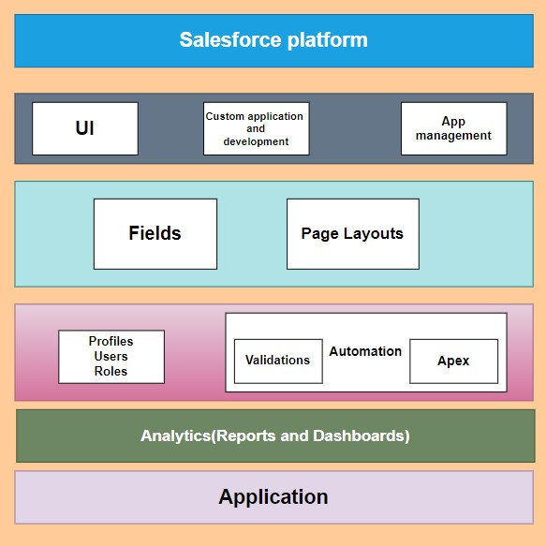

## 2.4 Functional Requirements

* **User Registration and Authentication:** Users should be able to create accounts with unique usernames and passwords. User authentication and authorization should be implemented to ensure data security.
* **Dashboard:** Users should have a personalized dashboard displaying key metrics such as the number of job applications submitted and the status of each application.
* **Job Application Tracking:** Users should be able to record details of each job application, including the job title, company, date applied, application status, and any related notes. Users should be able to filter and search through their job applications.
* **Job Postings:** Job postings from various recruiters should be accessible within the application. Users should be able to view details of job postings, such as job descriptions, qualifications, and application deadlines.
* **Custom Objects and Relationships:** Custom objects for job applications, job postings, and recruiters should be defined with appropriate relationships. Relationships between applicants and their job applications, as well as between job applications and job postings, should be established.
* **Profile Management:** Users should have the ability to edit their profiles and update personal information. Profiles should include user-specific settings and preferences.
* **Role-Based Access Control:** Access permissions should be defined based on user roles (e.g., applicant, recruiter). Users should only have access to data and features relevant to their roles.
* **User Management:** Administrators should be able to add, modify, or deactivate user accounts. User roles and permissions should be customizable.
* **Sharing Rules:** Sharing rules should be configured to allow data sharing based on predefined criteria, ensuring privacy and data access control.
* **Reporting:** Users should be able to generate custom reports based on their job application data. Standard reports and report templates should be available for common use cases.
* **Notifications and Reminders:** Users should receive notifications and reminders for application deadlines, interview schedules, and other important events. Notifications can be delivered via email or within the application.
* **Integration with External Platforms:** Integration with job search platforms or websites to import job postings automatically. Integration with email services to track application-related correspondence.
* **Data Import and Export:** Users should have the capability to import and export their application data for backup or transfer purposes.
* **User Adoption Features:** Onboarding guides, tutorials, and tooltips to help users navigate and effectively use the system. Feedback mechanisms to collect user suggestions and improve the application.
* **Customization and Configuration:** Administrators should be able to customize the application's appearance, fields, and workflows to suit their organization's needs.
* **Mobile Accessibility:** The application should be accessible on mobile devices to allow users to track job applications on the go.
* **Security and Data Privacy:** Data encryption, secure connections, and compliance with data privacy regulations (e.g., GDPR) should be implemented to protect user data.
* **Scalability:** The system should be scalable to accommodate a growing number of users, job applications, and job postings.
* **Backup and Recovery:** Regular data backups and a disaster recovery plan should be in place to prevent data loss.

# 

# 3.PREPARATION DATA MODELING

**Objects:**

Salesforce objects are database tables that permit you to store data that is specific to an organization. It consists of fields (columns) and records (rows).

Salesforce objects are of two types:

1.Standard Objects: Standard objects are the kind of objects that are provided by salesforce.com such as users, contracts, reports, dashboards, etc.

2.Custom Objects: Custom objects are those objects that are created by users. They supply information that is unique and essential to their organization. They are the heart of any application and provide a structure for sharing data.

In This Application We Use 7 Custom Objects:

1.Vehicle

2.Vehicles

3.Vehicle Object

4.Vehicle Name

5.Driver

6.Driver Name

7.Vehicle Type

**1)Create A Custom Object for Vehicle:**

1.From setup click on object manager.

2.Click create, select custom object.

3.Fill in the label as " Vehicle".

4.Fill in the plural label as " Vehicles ".

5.Record name: " Vehicle Name"

6.Select the data type as "Text".

7.In the Optional Features section, select Allow Reports and Track Field History.

8.In the Deployment Status section, ensure Deployed is selected.

9.In the Search Status section, select Allow Search.

10.In the Object Creation Options section, select Add Notes and Attachments related list to default page layout.

11.Leave everything else as is, and click Save.

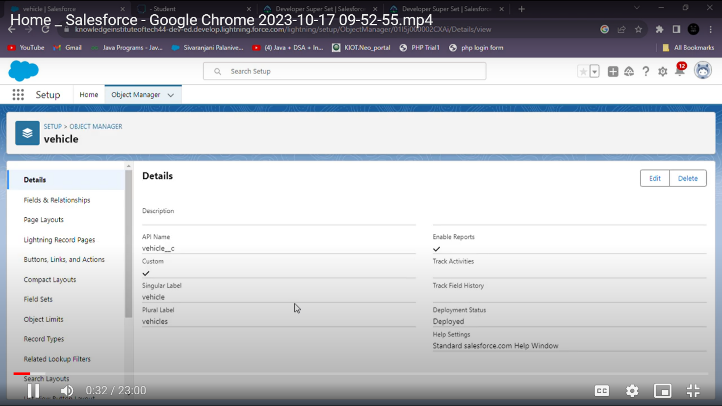

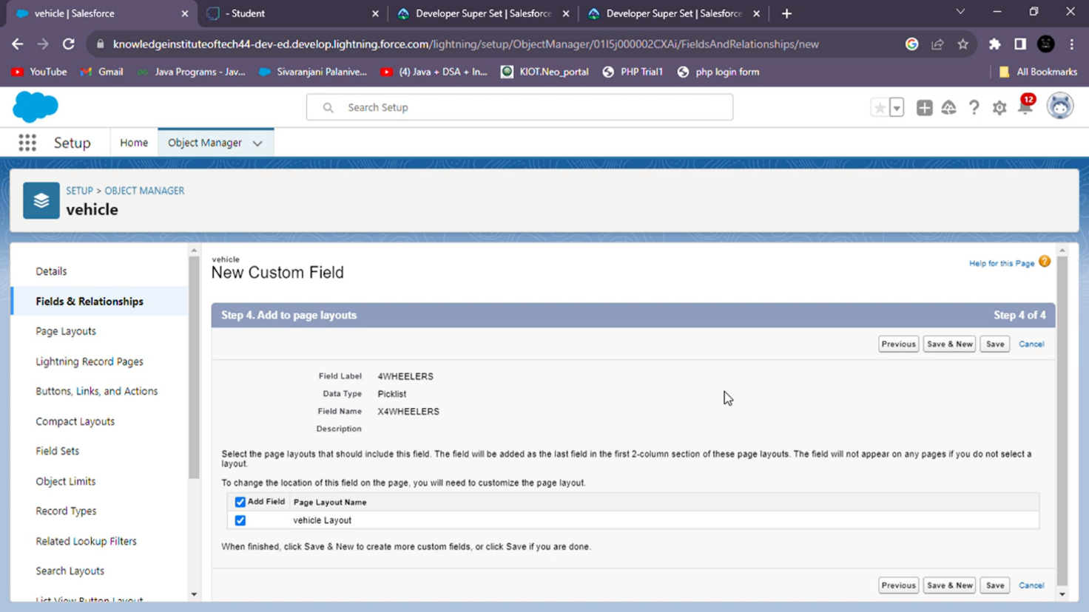

## 2)Creation of Vehicle Object

1.Click on the gear icon and then select Setup.

2.Click on the object manager tab just beside the home tab.

3.After the above steps, have a look on the extreme right you will find a Create Dropdown click on that and select Custom Object.

4.On the Custom Object Definition page, create the object as follows:

5.Label: Vehicle

6.Plural Label: Vehicle

7.Record Name: Vehicle Name

8.Select the data type as "Text".

9.Check the Allow Reports checkbox

10.Check the Allow Search checkbox

11.In the Object Creation Options section, select Add Notes and Attachments related list to default page layout 12.Click Save.

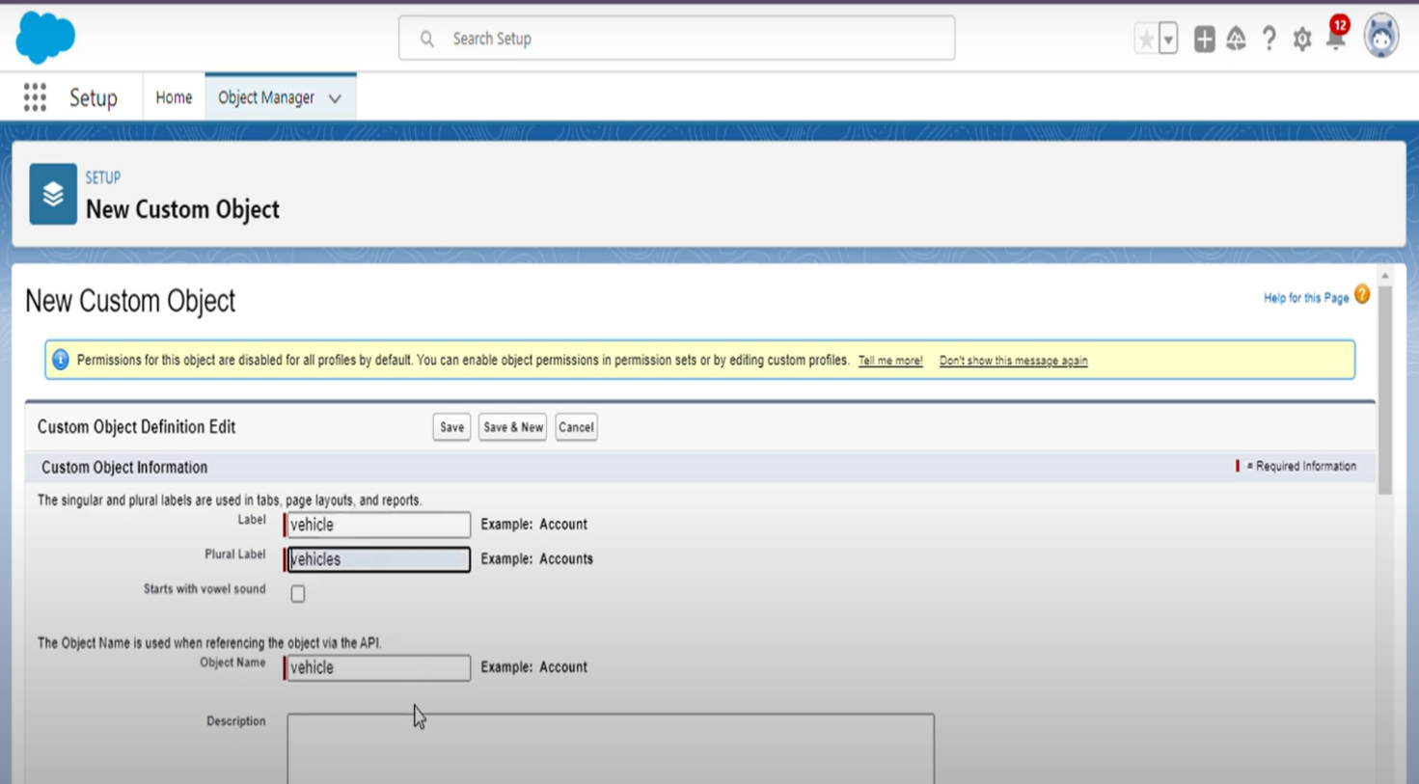

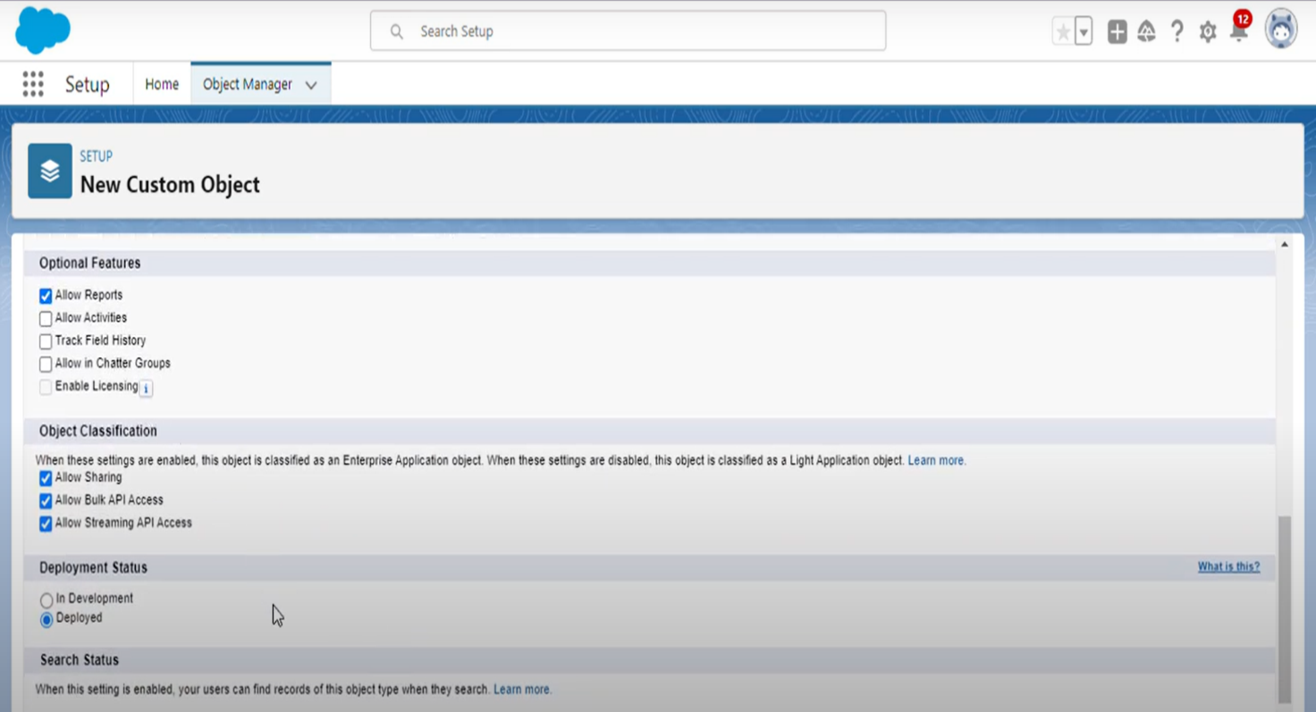

## 3)Creation of Fields and Relationship

1.Click on the gear icon and then select Setup.

2.Click on the object manager tab just beside the home tab.

3.After the above steps, have a look on the extreme right you will find a Create Dropdown click on that and select Custom Object.

4.On the Custom Object Definition page, create the object as follows:

5.Field Label: Vehicle Name

6. Length: 7

7. Field Name: Vehicle_Name

8.Select the data type as "Text".

9.Check the Allow Reports checkbox.

10.Check the Allow Search checkbox.

11.In the Object Creation Options section, select Add Notes and Attachments related list to default page layout.

12.Click Save.

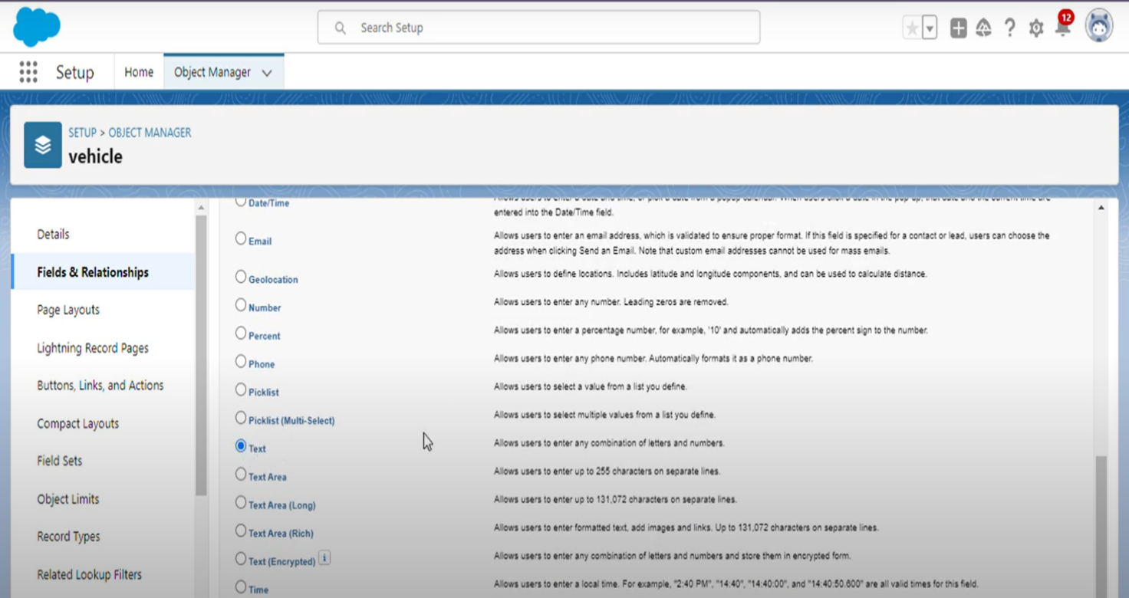

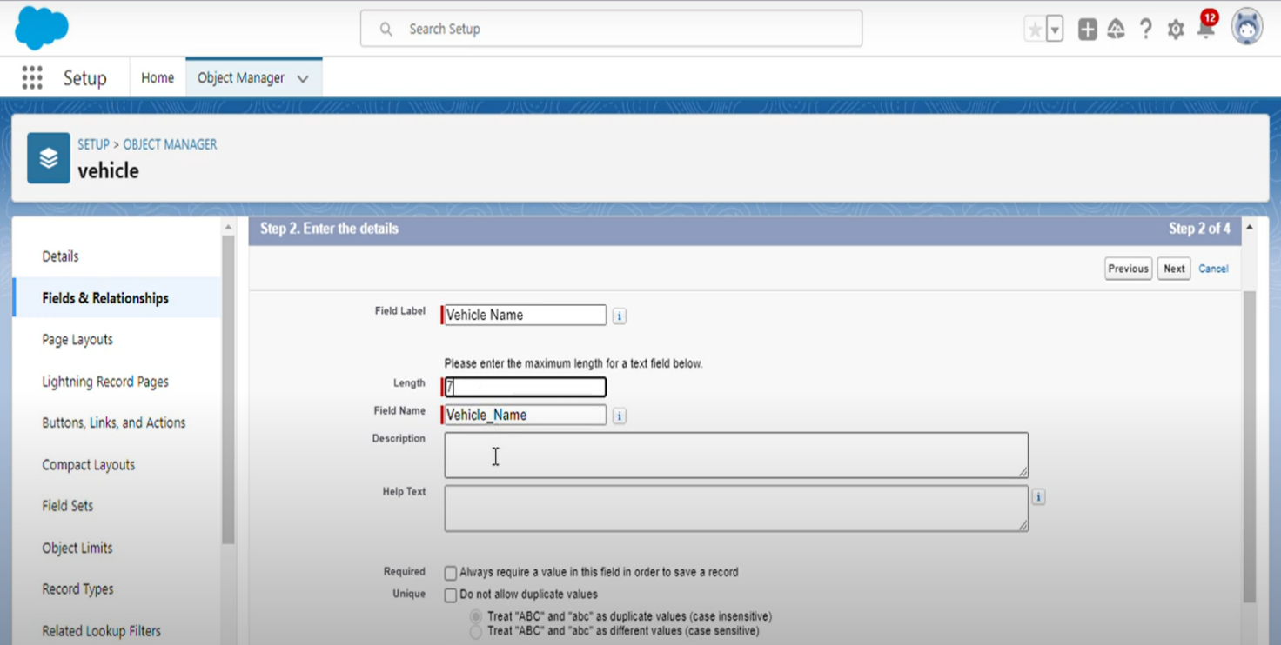

## 4)Creation of Fields

1.Click on the gear icon and then select Setup.

2.Click on the object manager tab just beside the home tab.

3.After the above steps, have a look on the extreme right you will find a Create Dropdown click on that and select Custom Object.

4.On the Custom Object Definition page, create the object as follows:

5.Field Label: Vehicle Type

6. Length: 7

7. Field Name: Vehicle_Type

8.Select the data type as "Picklist".

9.Check the Allow Reports checkbox.

10.Check the Allow Search checkbox.

11.In the Object Creation Options section, select Add Notes and Attachments related list to default page layout.

12.Click Save.

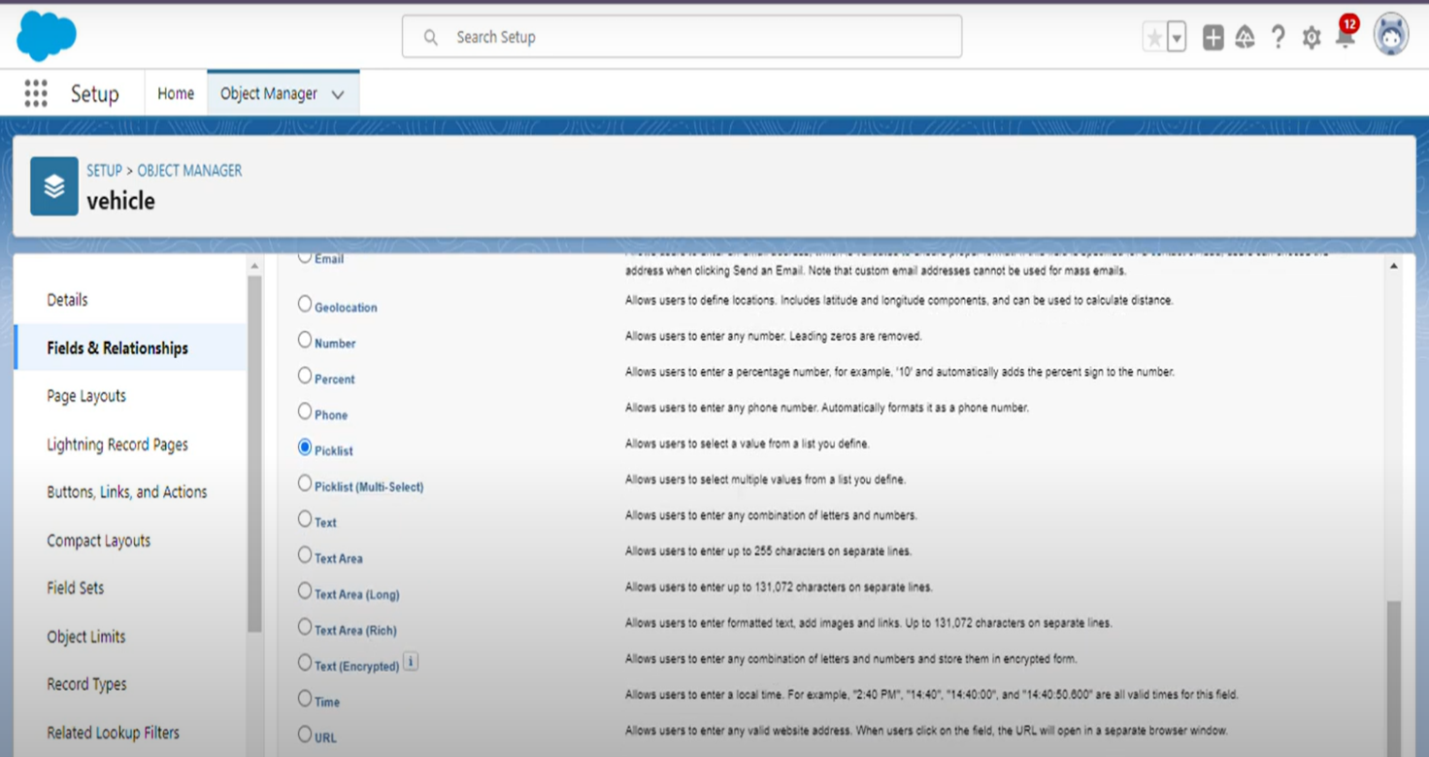

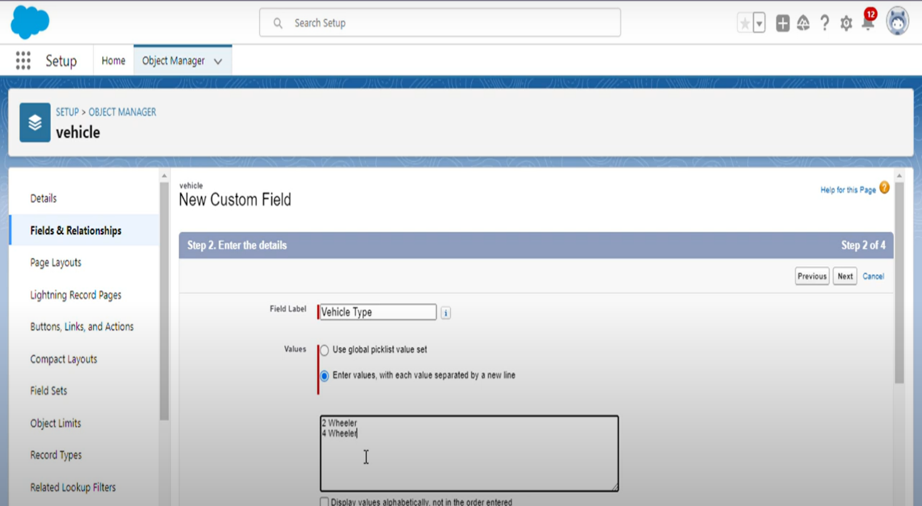

## 5) Creation of Fields

1.Click on the gear icon and then select Setup.

2.Click on the object manager tab just beside the home tab.

3.After the above steps, have a look on the extreme right you will find a Create Dropdown click on that and select Custom Object.

4.On the Custom Object Definition page, create the object as follows:

5.Field Label: 2WHEELERS

6.Select the data type as "Picklist".

7.Check the Allow Reports checkbox.

8.Check the Allow Search checkbox.

9.In the Object Creation Options section, select Add Notes and Attachments related list to default page layout.

10.Click Save.

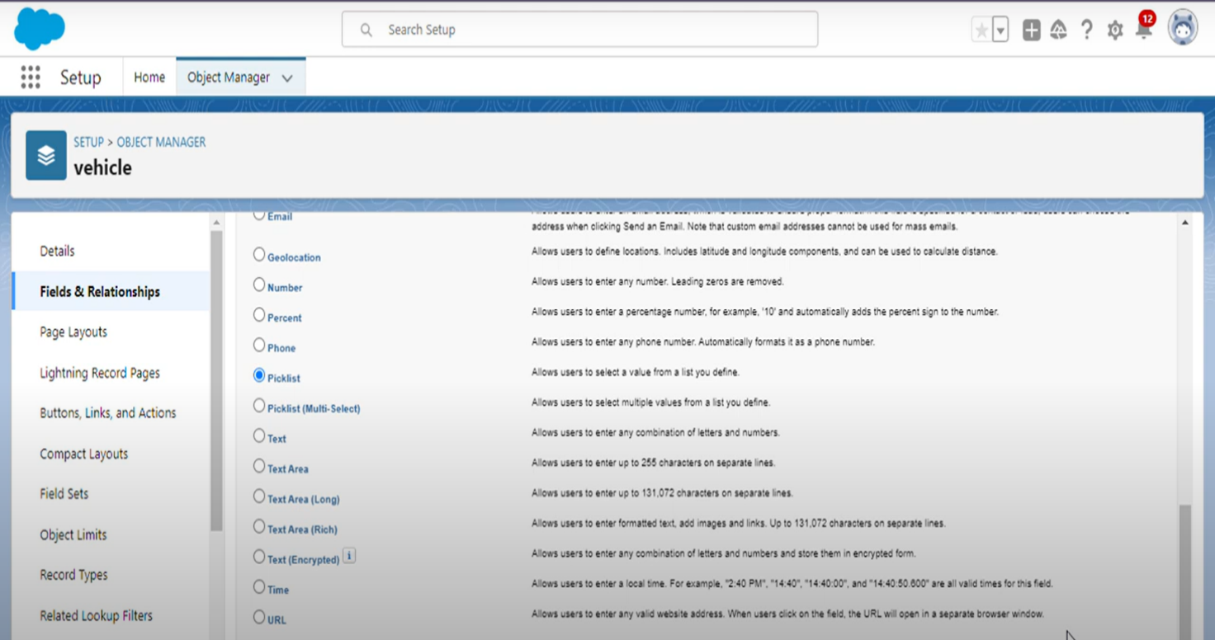

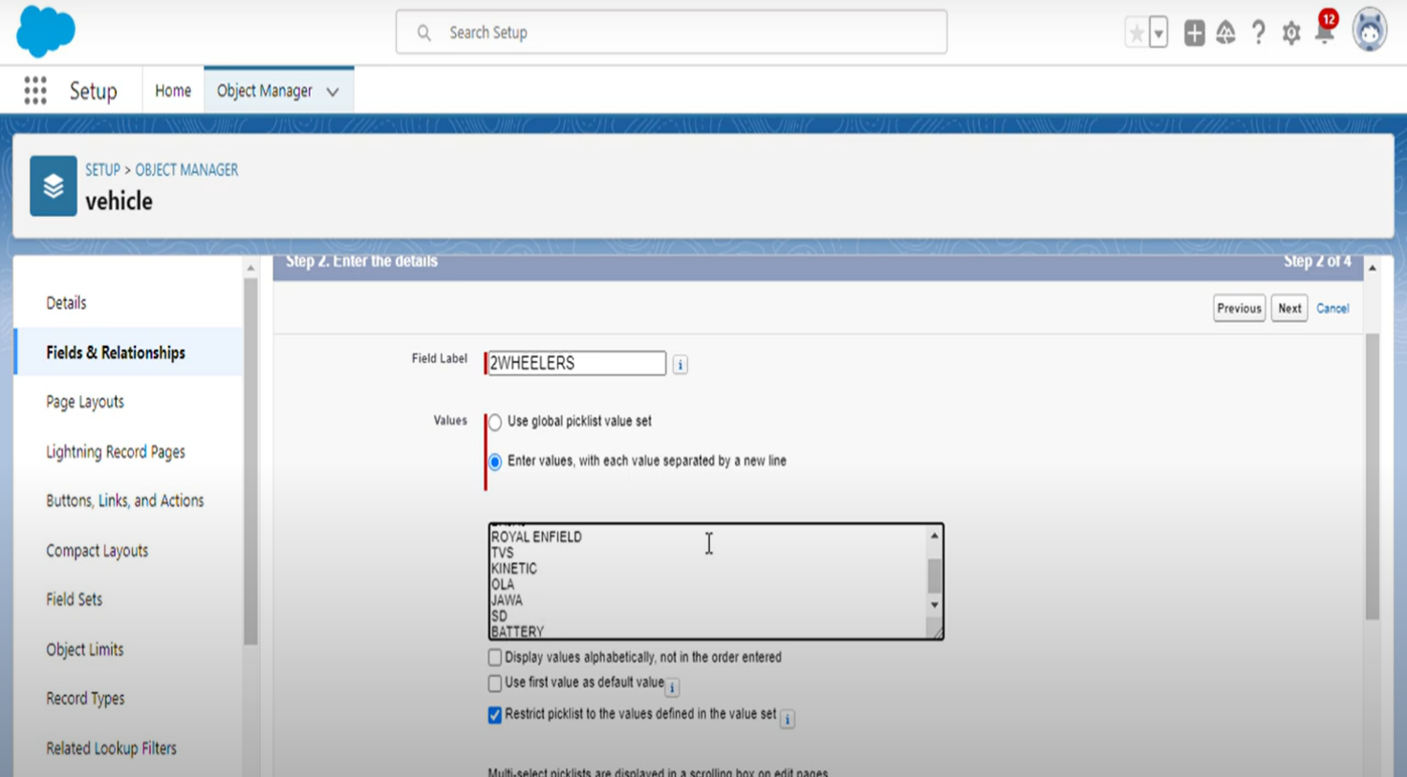

## 6) Creation of Fields

1.Click on the gear icon and then select Setup.

2.Click on the object manager tab just beside the home tab.

3.After the above steps, have a look on the extreme right you will find a Create Dropdown click on that and select Custom Object.

4.On the Custom Object Definition page, create the object as follows:

5.Field Label: 4 WHEELER

6.Select the data type as "Picklist".

7.Check the Allow Reports checkbox.

8.Check the Allow Search checkbox.

9.In the Object Creation Options section, select Add Notes and Attachments related list to default page layout.

10.Click Save.

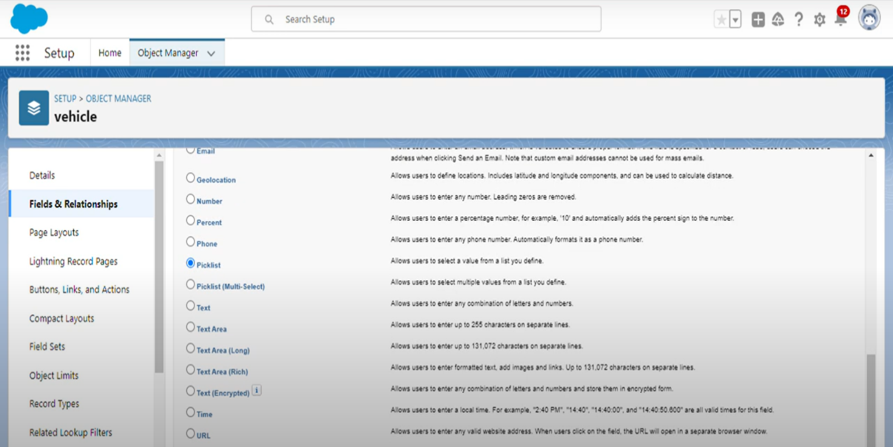

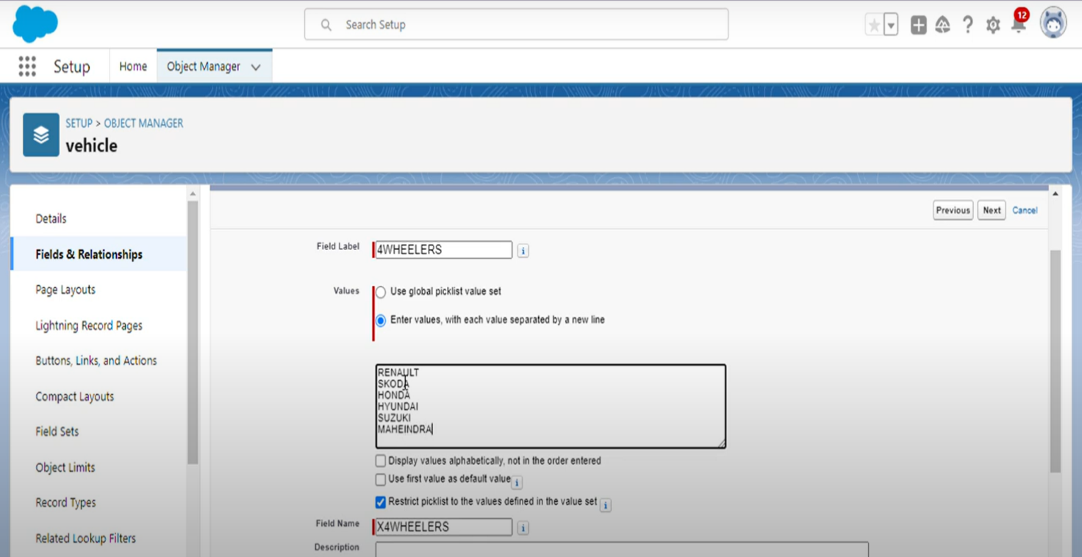

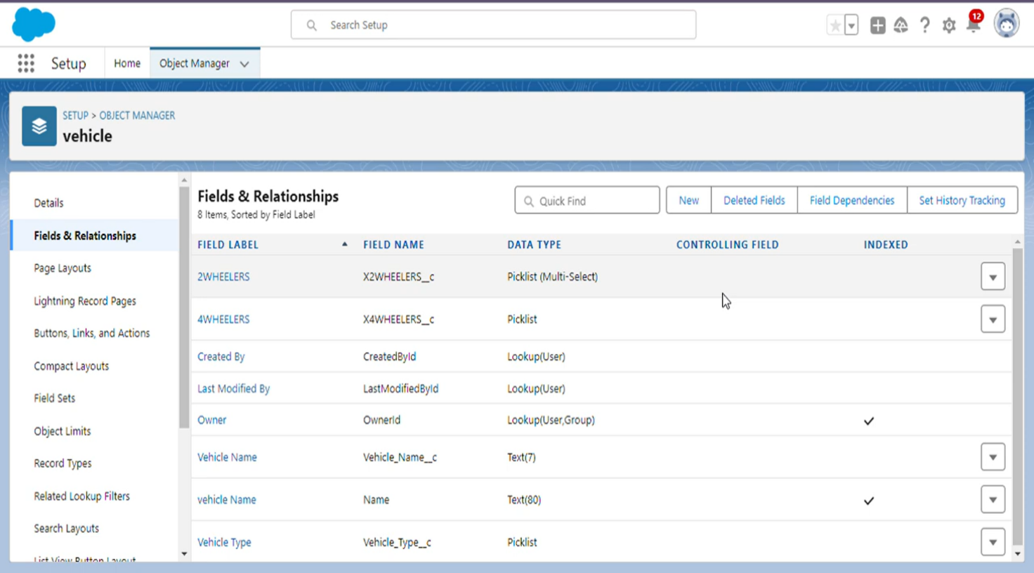

**7)Creation of Page Layout**

1.Click on the App Launcher and then select Object Manager.

2.Click on the object manager tab just beside the home tab.

3.Select the Page Layout just below the fields and relationship .

4. Click new and create the layout for the field name vehicle

5.Page Layout Name: vehicle Layout

6.Click Save.

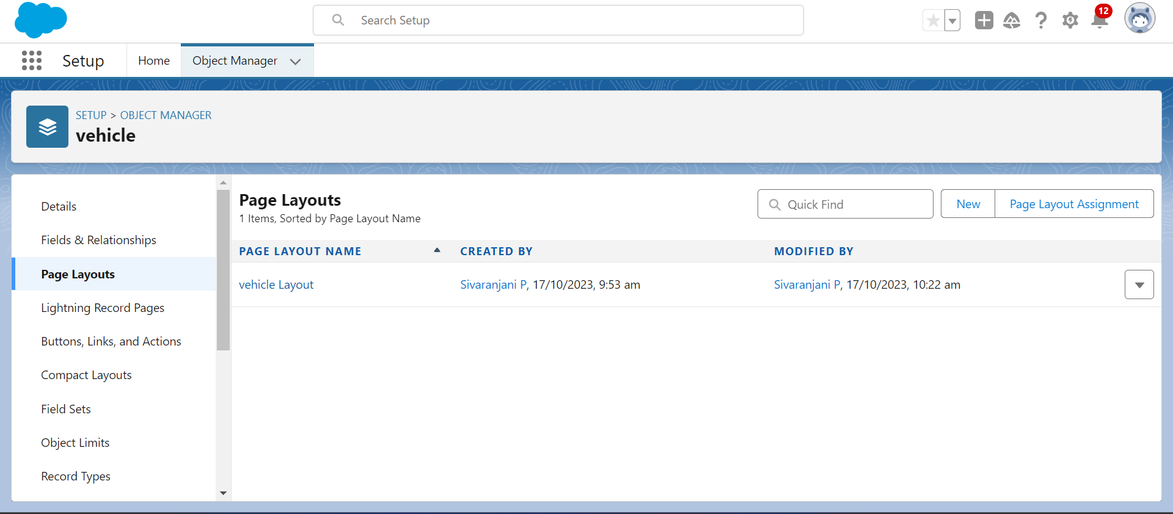

**8)Creation of Vehicle Management App**

1.From Setup, enter App Manager in the Quick Find and select App Manager.

2.Click New Lightning App. Enter Vehicle Management as the App Name, then click Next

3.Under App Options, leave the default selections and click Next.

4.Under Utility Items, leave as is and click Next.

5.From Available Items, select Accounts, Contacts, Opportunities, Vehicle, Driver, Travelers, Reports, and Dashboards and move them to Selected Items. Click Next.

6.From Available Profiles, select System Administrator and move it to Selected Profiles. Click Save & Finish.

7.To verify your changes, click the App Launcher, type Vehicle Management and select the Vehicle Management app

8.Click Save and finish**.**

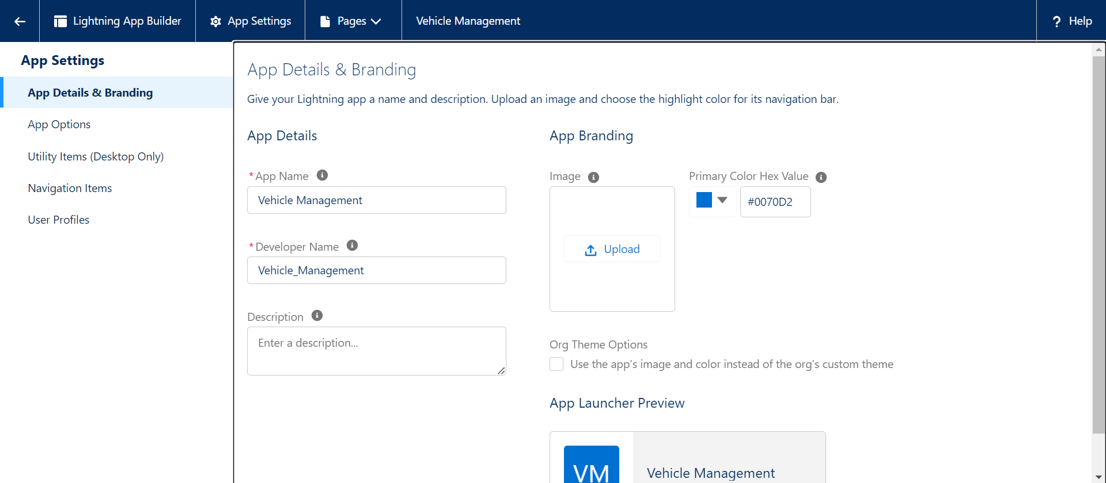

**9)Creation of profile**

1.From Setup enter Profiles in the Quick Find box, and select Profiles.

2.From the list of profiles, find Standard User.

3.Click Clone.

4.For Profile Name, enter Vehicle Manager.

5.Click Save.

6.While still on the Vehicle Manager Profile page, then click Edit.

7.Scroll down to Custom Object Permissions and give access for Create, Read, Edit, and Delete, View all and modify all for Vehicle object Driver object and Traveler object.

To create a new profile:

1.Go to setup

2.Type profiles in quick find box

3.Click on profiles

4.Clone the desired profile (standard user is preferable)

5.Enter profile name

6.Save

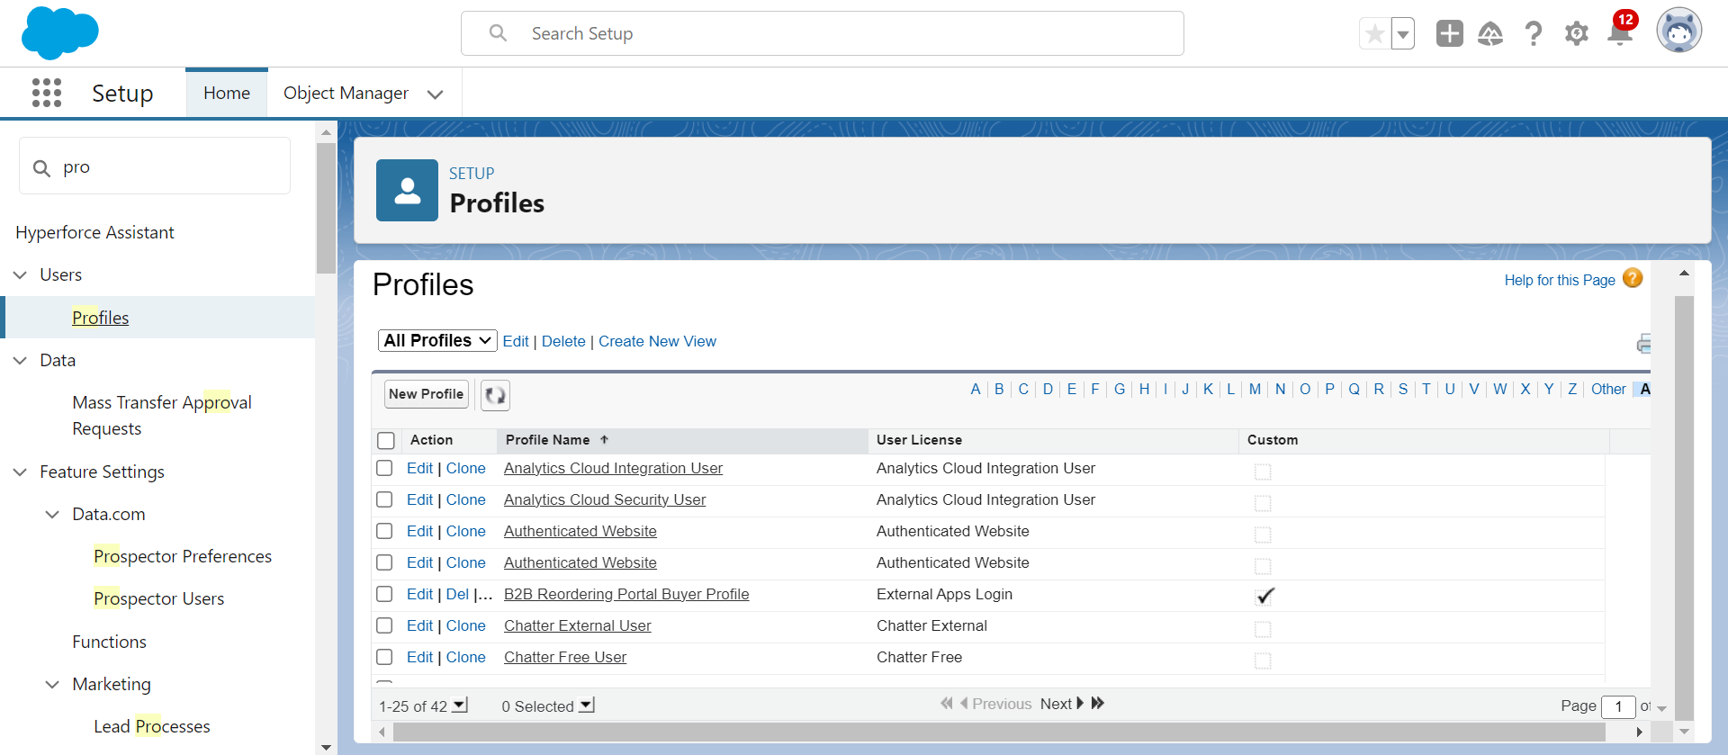

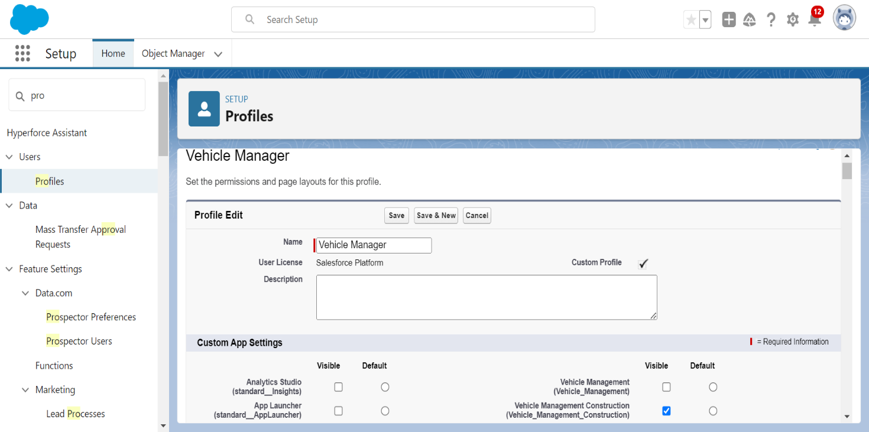

**10)Creation of User**

1. From Setup, in the Quick Find box, enter Users, and then select Users.
2. Click New User.
3. Enter the user’s name John Teddy and (Your) email address and a unique username in the form of an email address. By default, the username is the same as the email address.
4. Select a **Role**(Vehicle Manager)
5. Select a User License As salesforce.
6. Select a profile as Vehicle Manager.

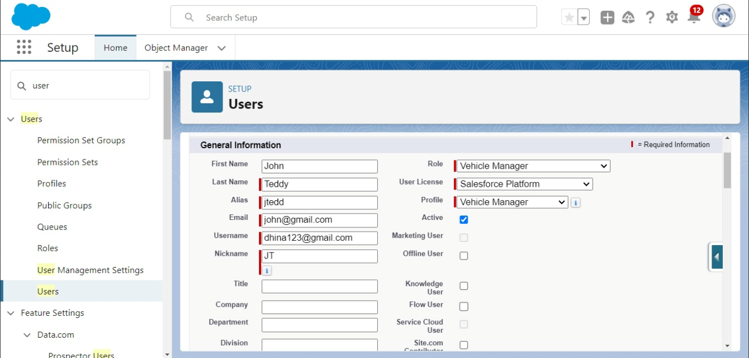

**11)View Record (Vehicle):**

1.Click on App Launcher on left side of screen.

2.Search Vehicle Management System & click on it.

3.Click on Vehicle Tab.

4.Click on any record name. you can see the details of the Vehicle

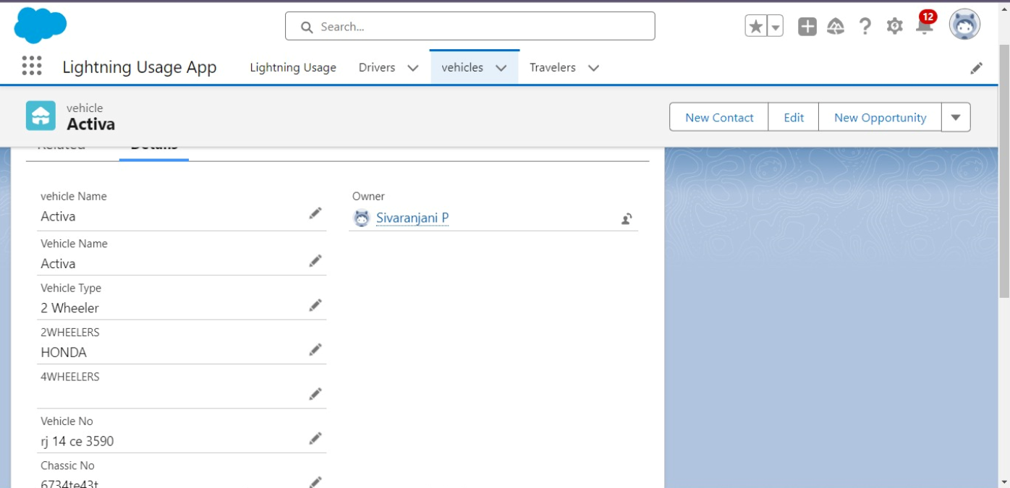

**12)Delete Record (Vehicle):**

1.Click on App Launcher on left side of screen.

2.Search Vehicle Management System & click on it.

3.Click on Vehicle Tab.

4.Click on Arrow at right hand side on that Particular record.

5.Click delete and delete again.

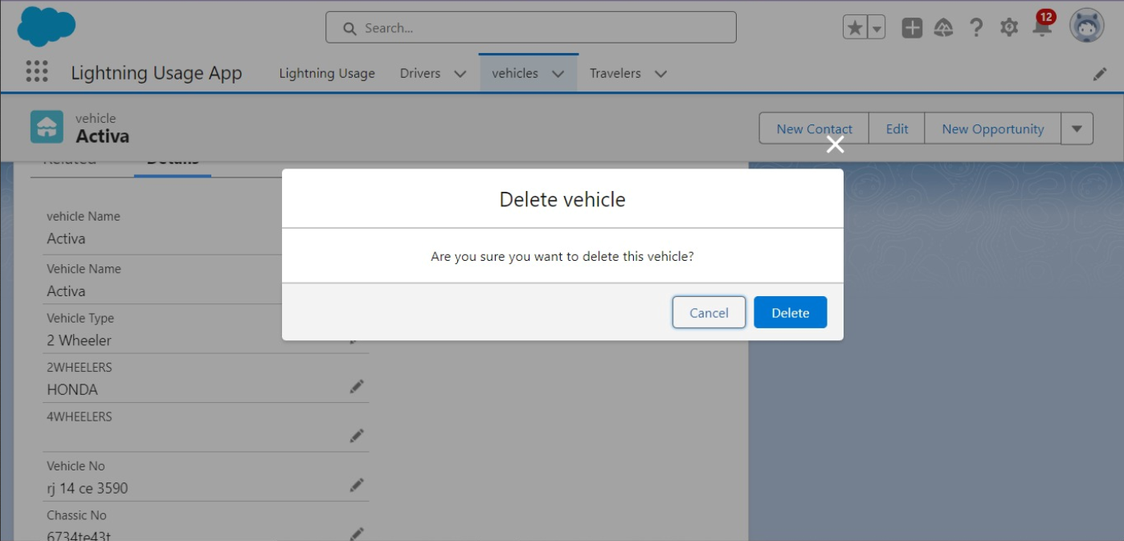

**13) Creation of Report**

1.Click on the App Launcher and then select Object Manager.

2.Click on the object manager tab just beside the home tab.

3.Select the Report that is above the page in Vehicle Management Page.

4. Click new and create the new report for the Vehicle Management

5.Report Name: New Opportunities Report

6.Click Save.

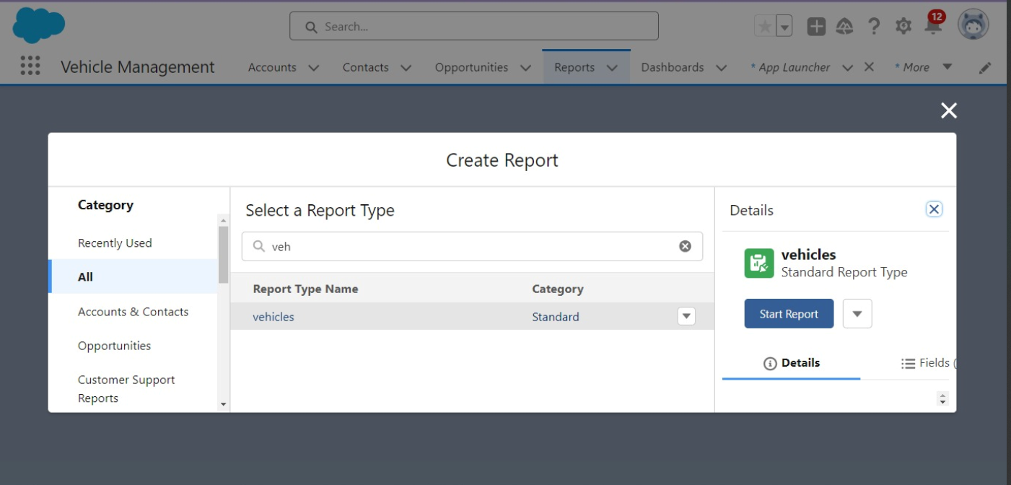

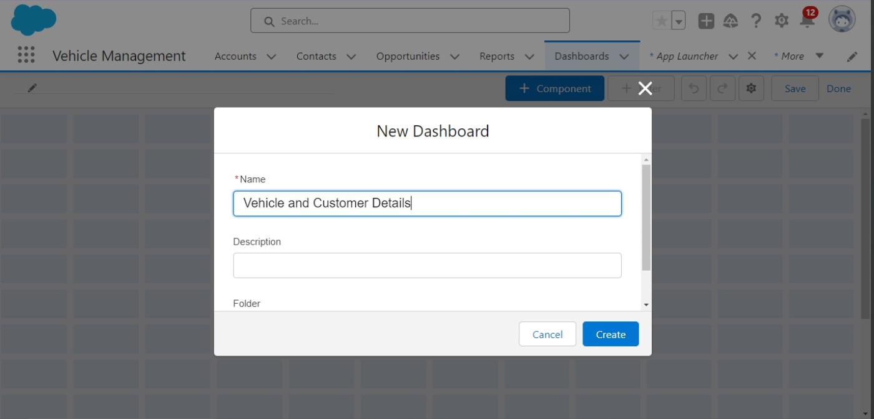

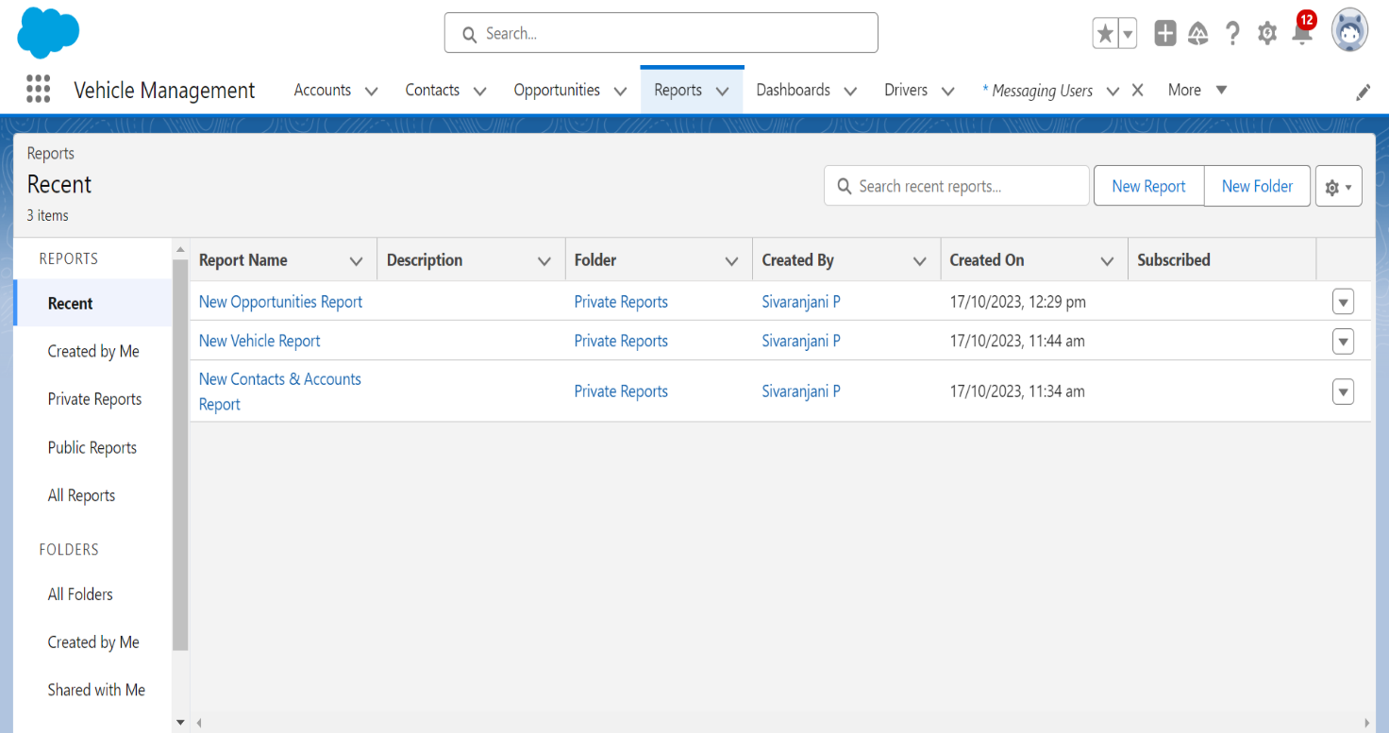

**14)Creation of Dashboard**

1.Click on the App Launcher and then select Object Manager.

2.Click on the object manager tab just beside the home tab.

3.Select the Dashboard that is above the page in Vehicle Management Page.

4. Click new and create the new dashboard for the Vehicle Management

5.Dashboard Name: Vehicle and customer details

6.Click Save.

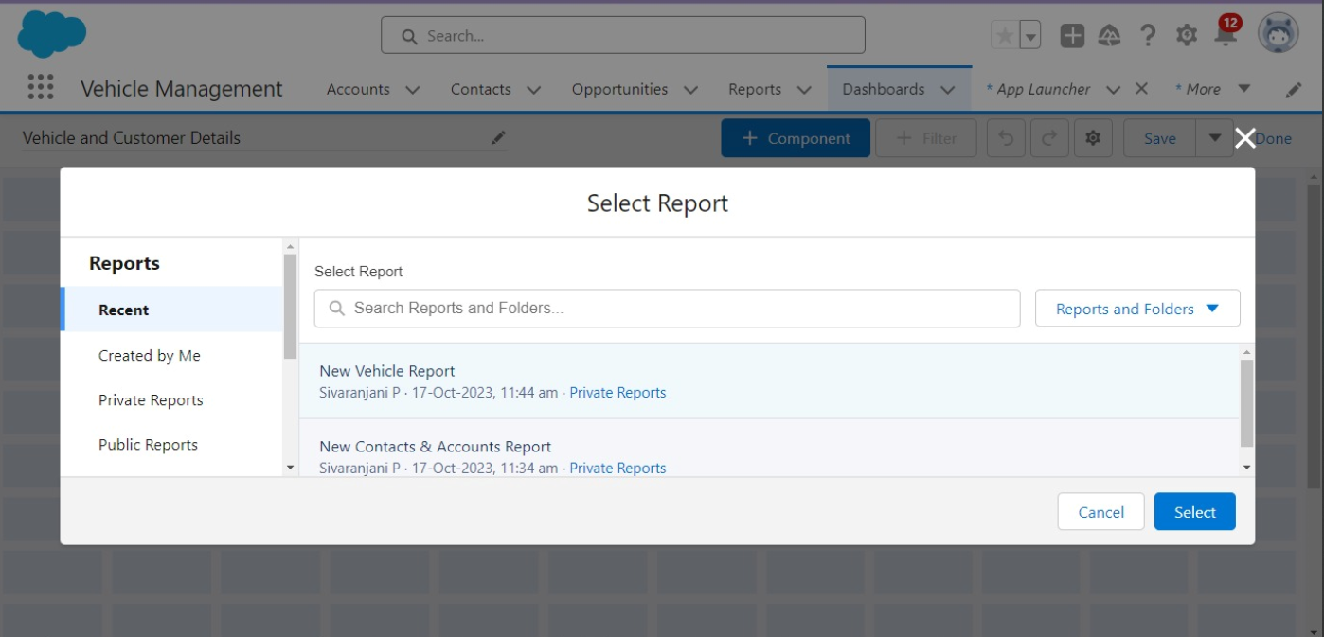

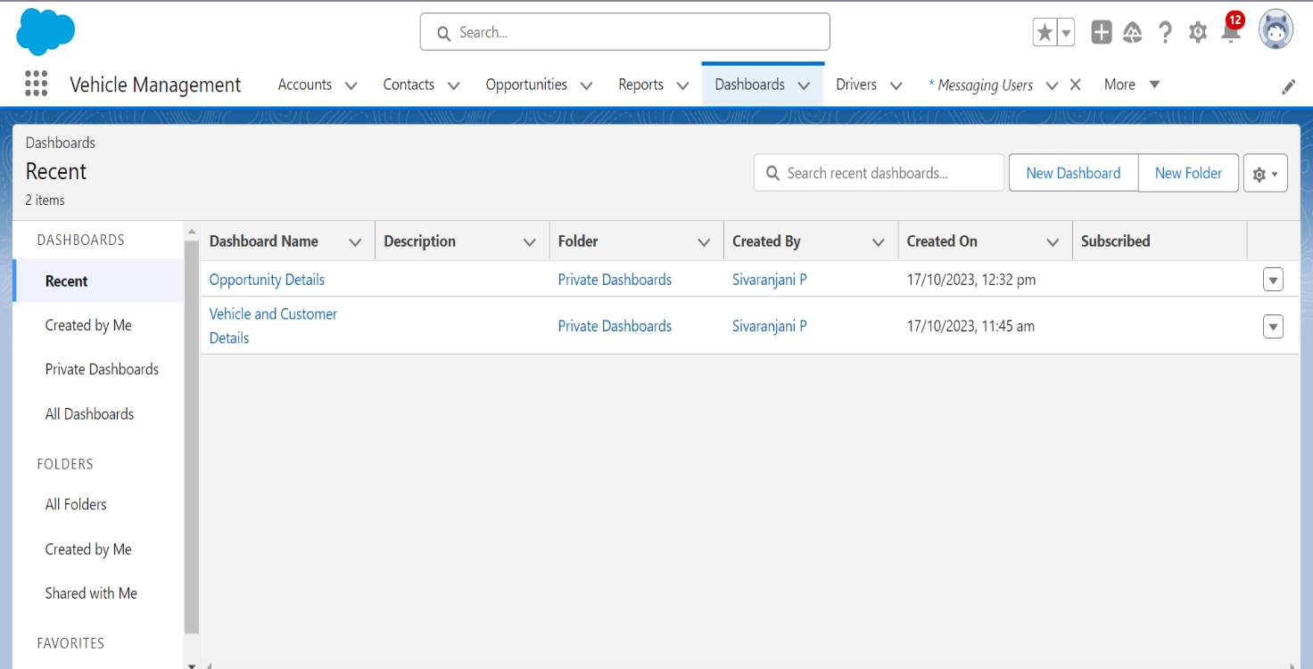

**15)Report Viewing**

1.Click on App Launcher on left side of screen.

2.Search Vehicle Management System & click on it.

3.Click on Reports Tab.

4.Click on Opportunity Details report and see records

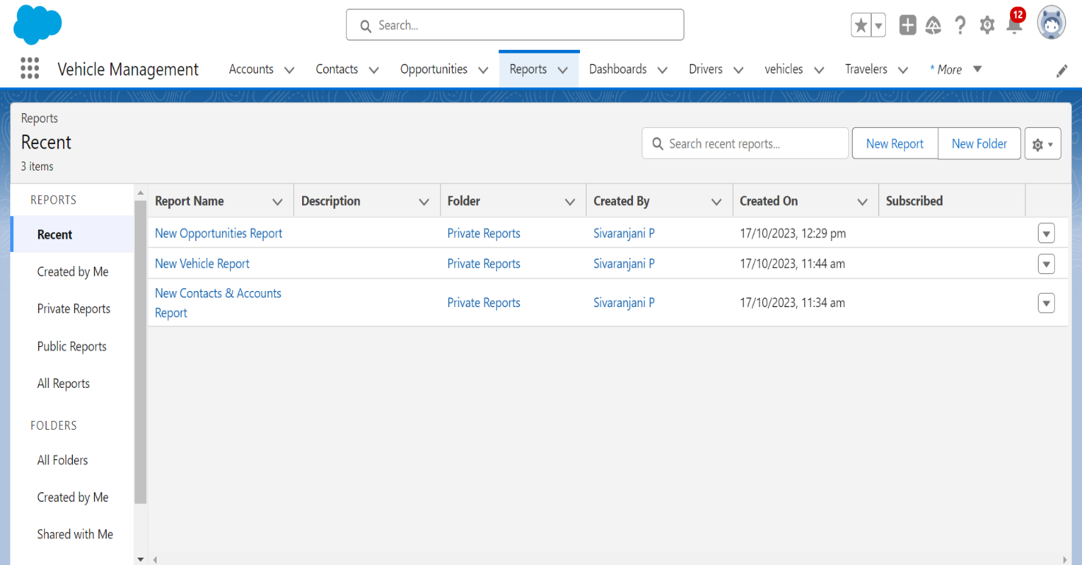

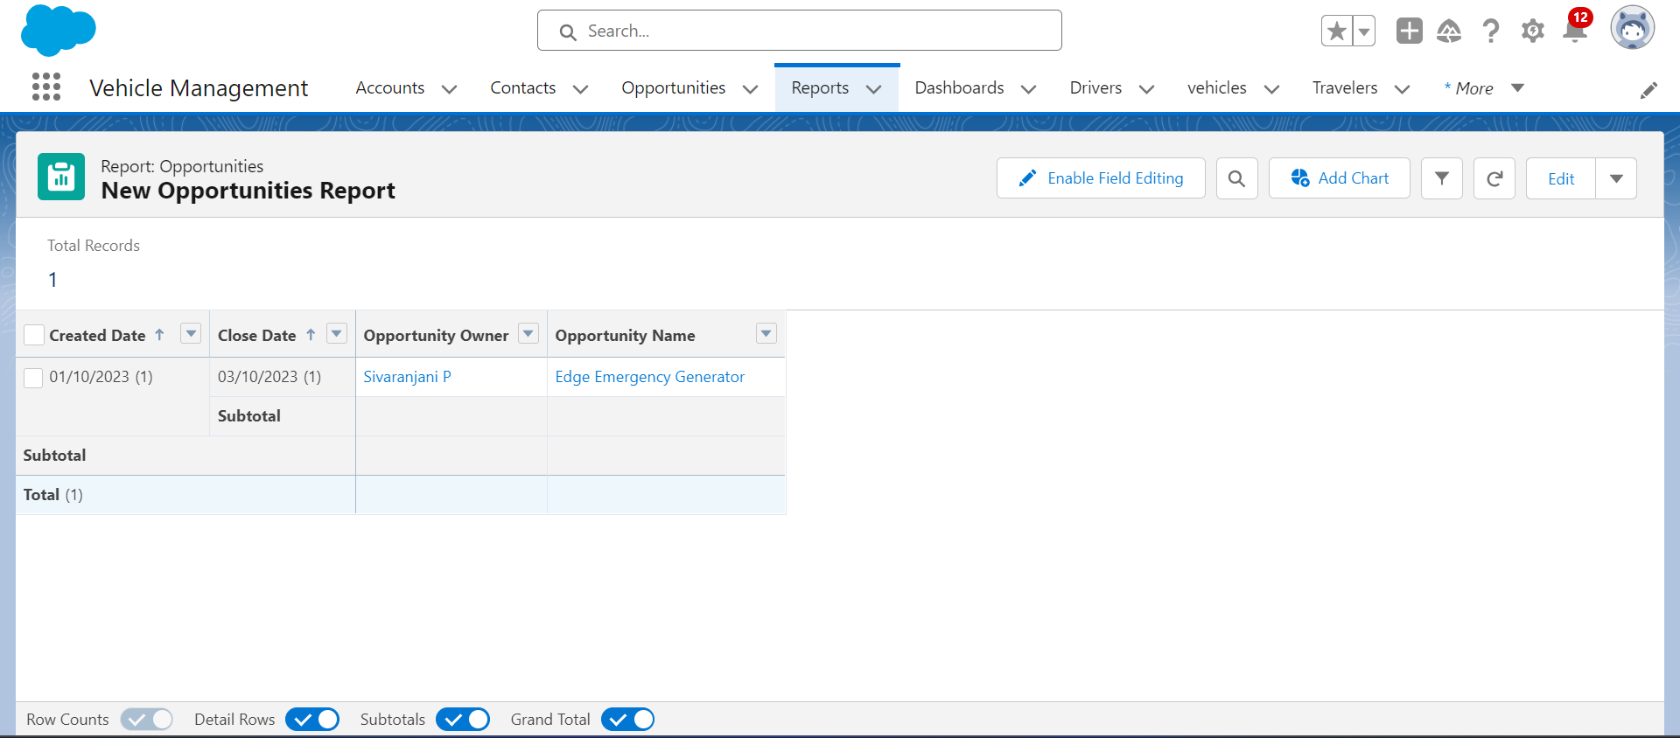

**16)Dashboard Viewing**

1.Click on App Launcher on left side of screen.

2.Search Vehicle Management System & click on it.

3.Click on Dashboard Tab.

4.Click on Opportunity and Dashboard and see graph view of records

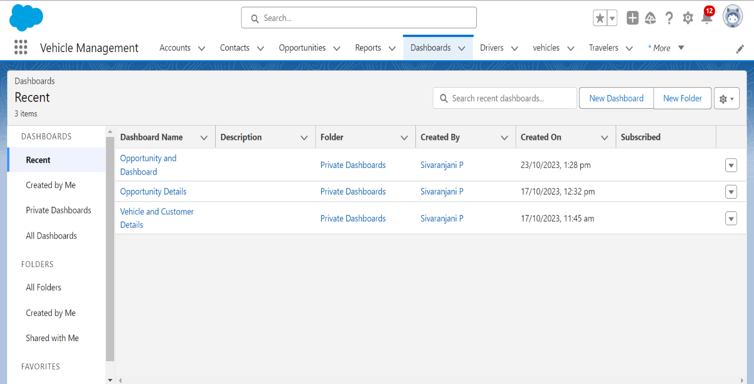

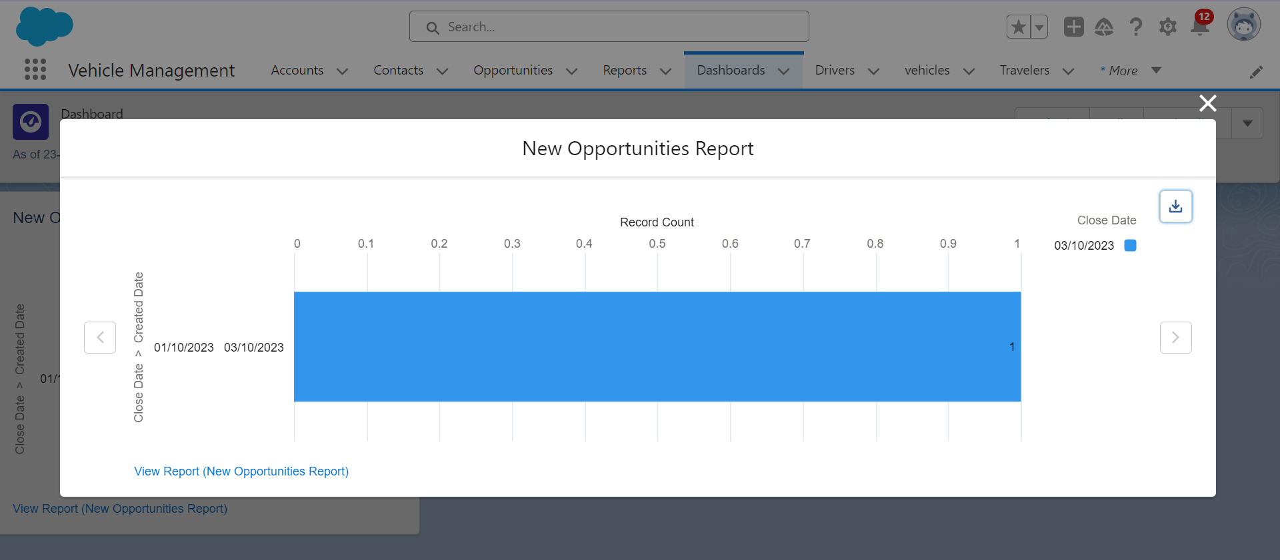

### **17)Creation Of Approval Process**

Click Setup and select Setup.

1. Select Process Automation | Approval Processes (or use the Quick Find and search for Approval Processes)
2. In the Manage Approval Processes For list, select Driver.
3. Click Create New Approval Process and select Use Jump Start Wizard.
4. Enter the following parameters

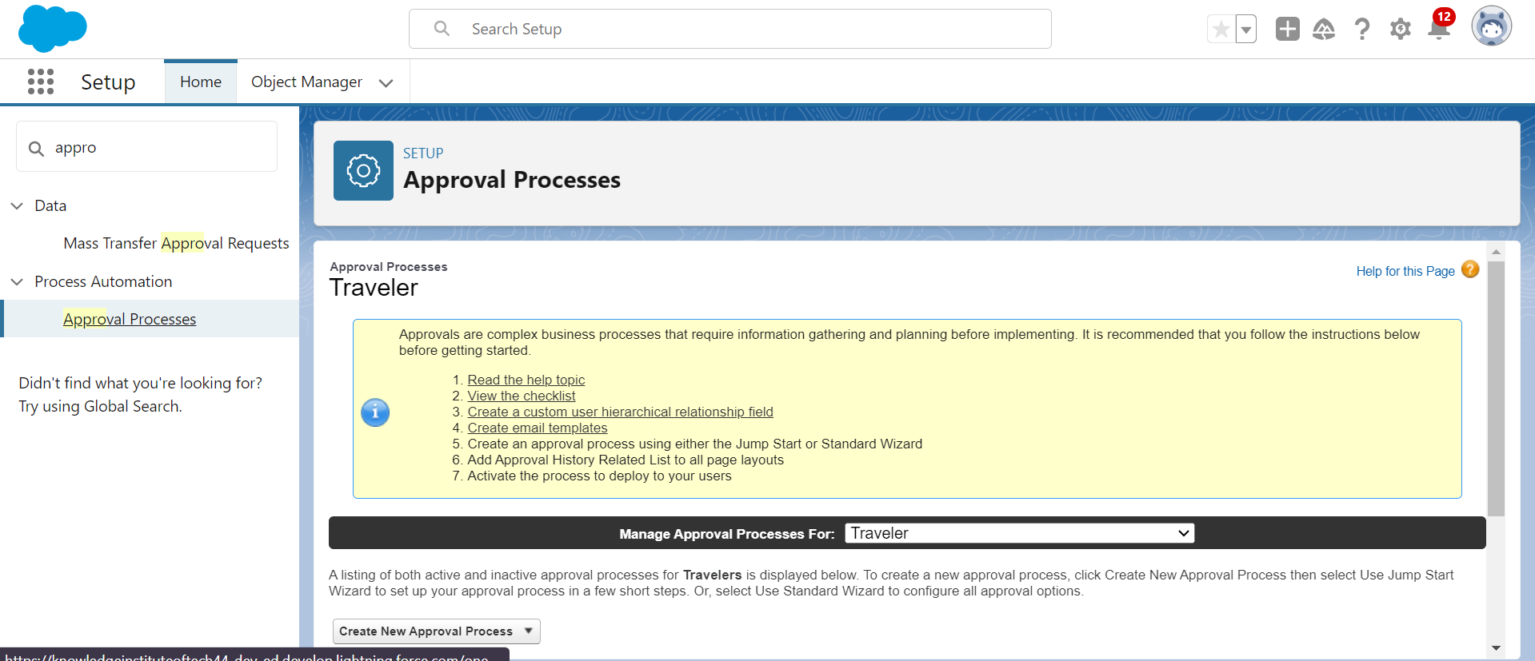

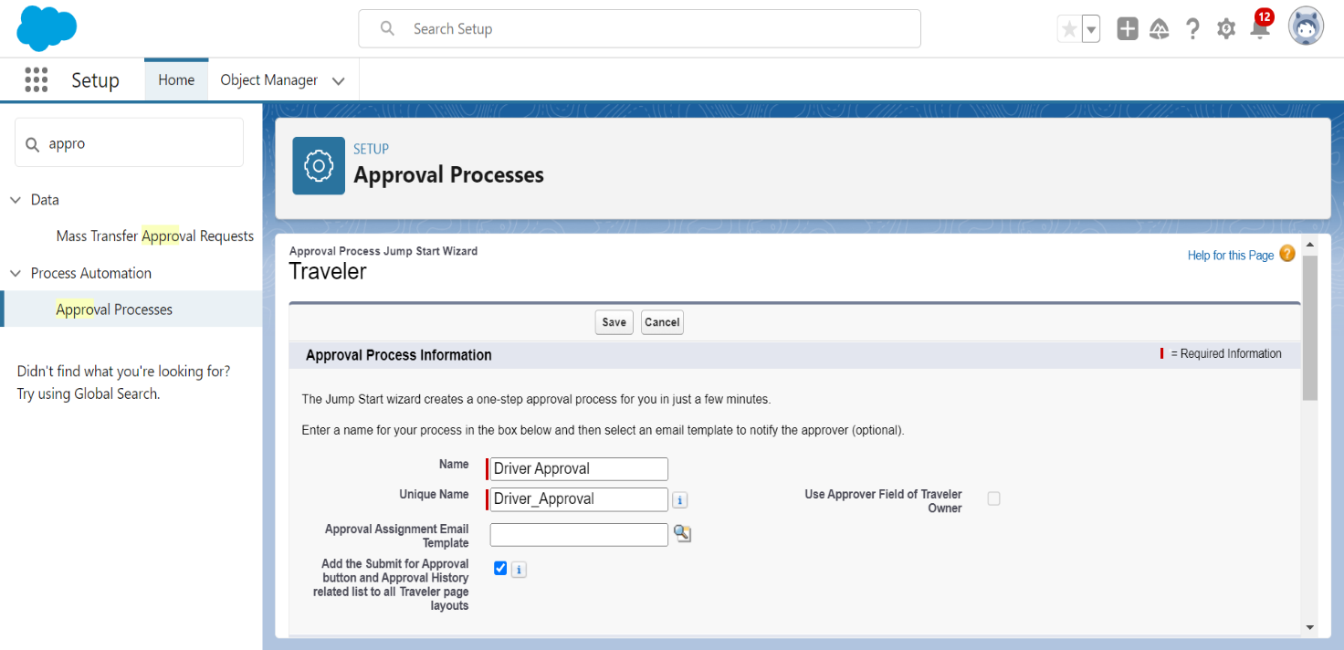

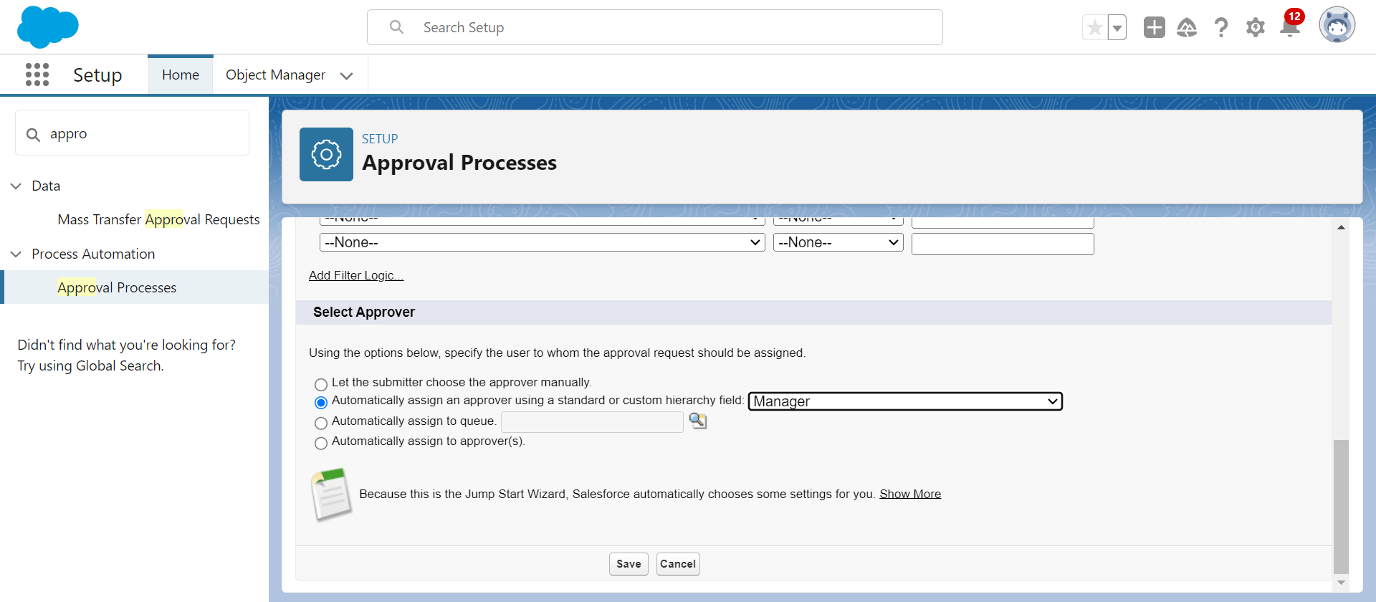

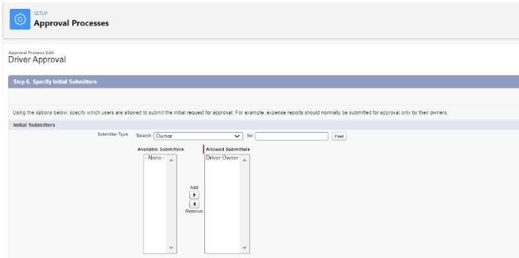

# 5.AUTOMATION

**Flow:**

Flows in Salesforce, a flow is a tool that automates complex business processes. Simply put, it collects data and then does something with that data. Flow Builder is the declarative interface used to build individual flows. Flow Builder can be used to build code-like logic without using a programming language. Flows fall into five categories:

1.Screen Flows

2.App Page Setting

### **1.Creation Of Screen Flow**

1. Click on Gear icon and select setup
2. In Quick find Box enter flow and select the flows
3. Click on New flow and Select Screen flow
4. It will open the canvas. Select (+)
5. Select the screen element from the drop down.
6. It will open the dialog box. Now give the label name and api name will be auto populated. These labels are for your screen Element.
7. Label:DriverInfo
8. API Name: Driver_Info (This field will be auto populated.)
9. In search Component type text and drag the text component to canva and give the label and api Name

10.Label: Driver Name  
 11.API Name: Driver_Name (This field will be auto populated.)

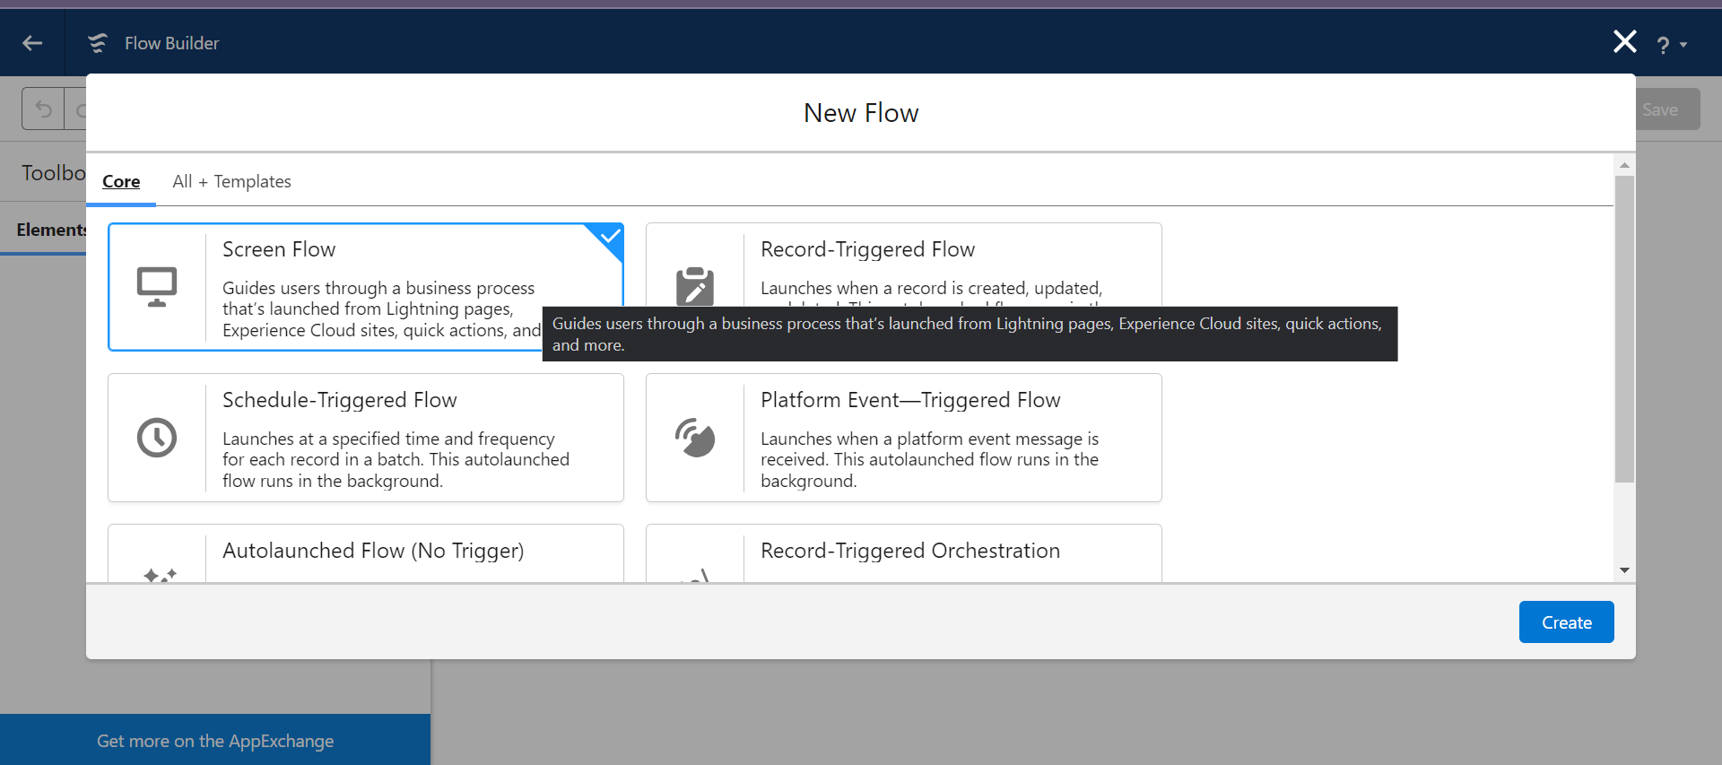

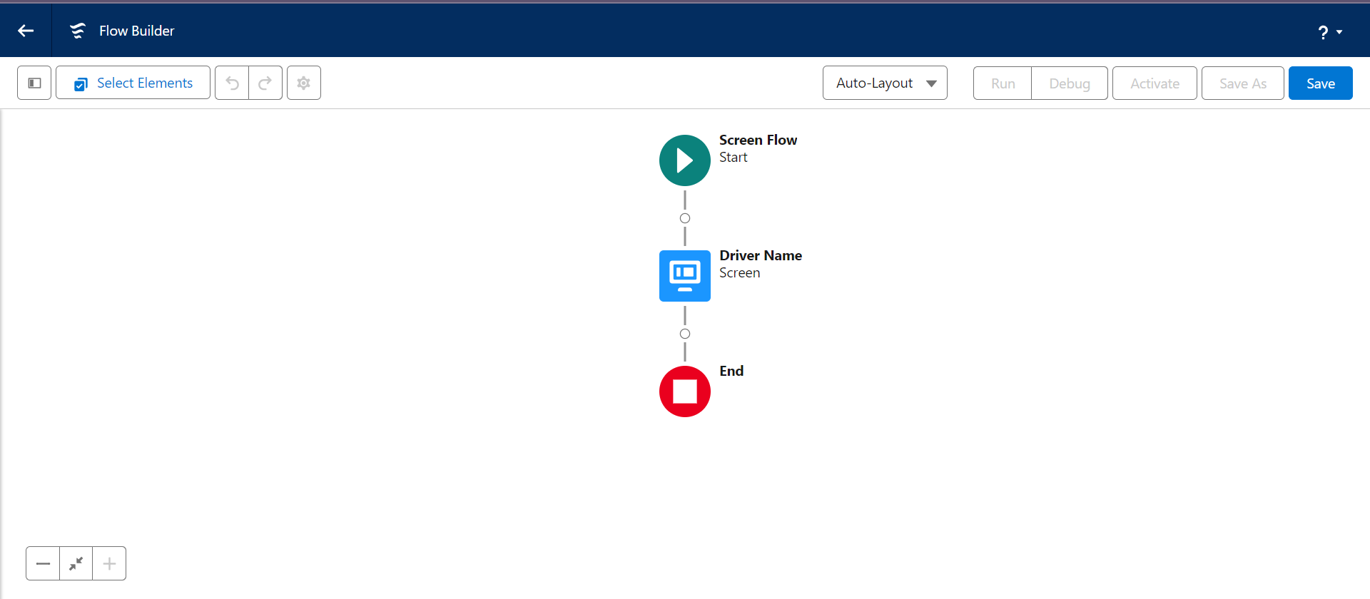

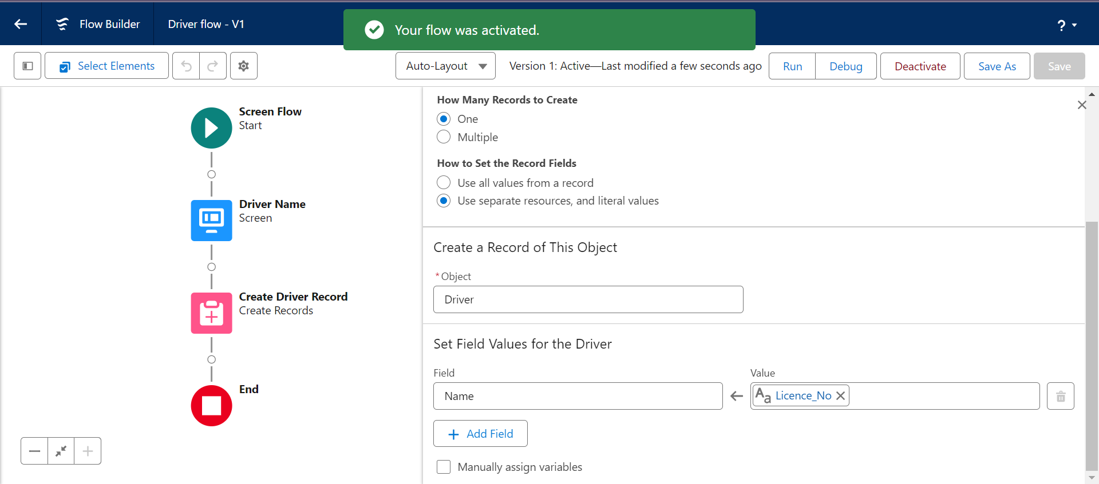

### **2.App Page Settings**

1. Click on the Gear icon and select set up
2. In Quick Find box. Type App Manager and select the App Manager
3. Select Vehicle Management and Click on drop down beside and select Edit
4. Select Utility Items and Click on Add Utility Items
5. Search for Flow and click on flow
6. Now Label: Driver Flow
7. Scroll Down in Flow Select Driver Screen Flow
8. Click on Save
9. Now Go to App Builder and Select Vehicle Management App

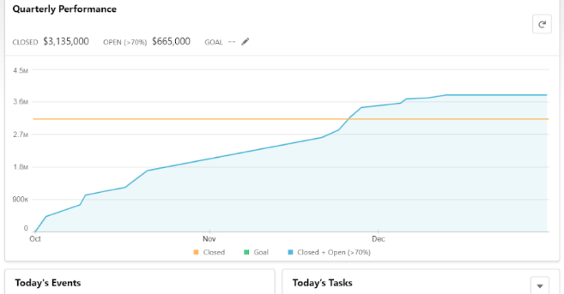

**11)View Record (Vehicle):**

1.Click on App Launcher on left side of screen.

2.Search Vehicle Management System & click on it.

3.Click on Vehicle Tab.

4.Click on any record name. you can see the details of the Vehicle



**12)Delete Record (Vehicle):**

1.Click on App Launcher on left side of screen.

2.Search Vehicle Management System & click on it.

3.Click on Vehicle Tab.

4.Click on Arrow at right hand side on that Particular record.

5.Click delete and delete again.



**13) Creation of Report**

1.Click on the App Launcher and then select Object Manager.

2.Click on the object manager tab just beside the home tab.

3.Select the Report that is above the page in Vehicle Management Page.

4. Click new and create the new report for the Vehicle Management

5.Report Name: New Opportunities Report

6.Click Save.







**14)Creation of Dashboard**

1.Click on the App Launcher and then select Object Manager.

2.Click on the object manager tab just beside the home tab.

3.Select the Dashboard that is above the page in Vehicle Management Page.

4. Click new and create the new dashboard for the Vehicle Management

5.Dashboard Name: Vehicle and customer details

6.Click Save.





**15)Report Viewing**

1.Click on App Launcher on left side of screen.

2.Search Vehicle Management System & click on it.

3.Click on Reports Tab.

4.Click on Opportunity Details report and see records





**16)Dashboard Viewing**

1.Click on App Launcher on left side of screen.

2.Search Vehicle Management System & click on it.

3.Click on Dashboard Tab.

4.Click on Opportunity and Dashboard and see graph view of records





GitHub & Project Video Demo Link

GitHub Link:

<https://github.com/jo-canva/naanmudhalvan-2>

Project Video Demo Link:

https://drive.google.com/file/d/1ouUiqHCLZacEYYBcJbQj7tnohF1yKa-z/view?usp=sharing